

**ACO LAB**

**EXPERIMENT 5**

**Name-Ritik Kumar**

**Sap Id-500097106**

**Roll no-R2142211330**

**Batch-4 (DevOps)**

**AIM: Working with Dockerfile to Build and Push Docker Image**

**Steps to Complete:**

1. Create following Dockerfile

FROM alpine

MAINTAINER SUDIPT

RUN apk update

RUN apk add nodejs

RUN mkdir /app

COPY index.js /app

WORKDIR /app

RUN node index.js

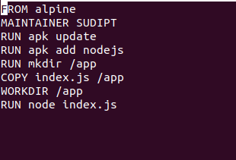

1. Now we have dockerized the app, we will Build image from Dockerfile.

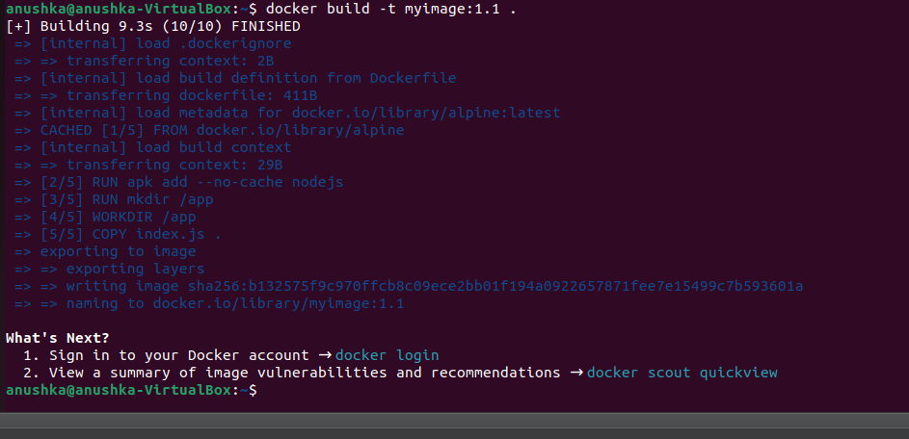

1. Create account on Dockerhub and create a repository in it.

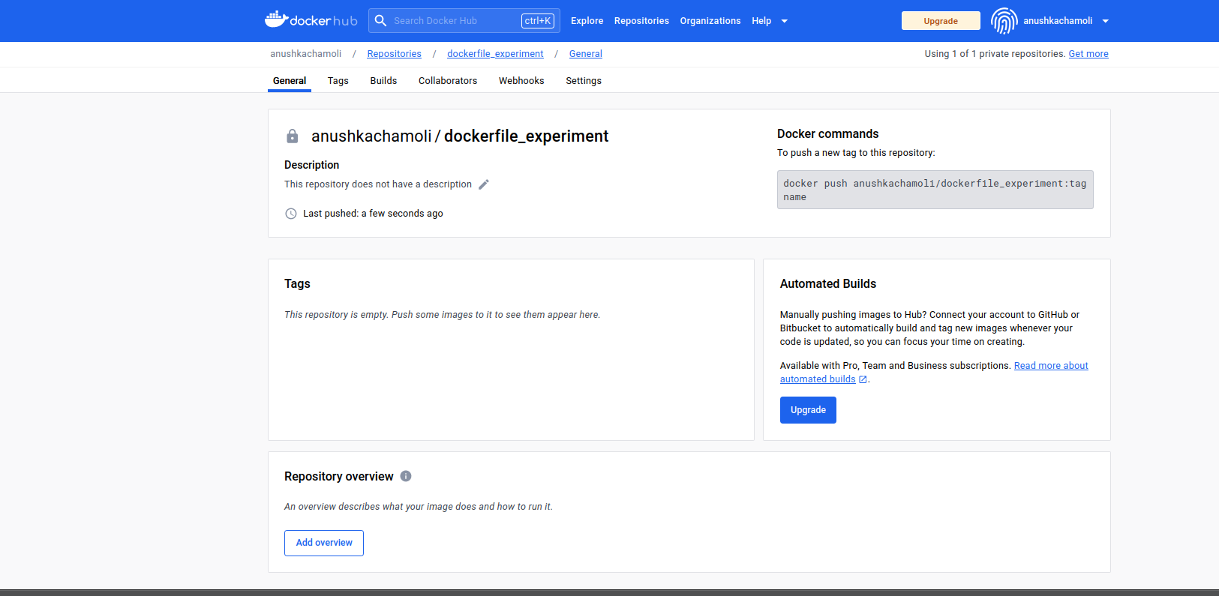

1. Tag the recently created image using following command.



1. Login to Dockerhub from console using following command.

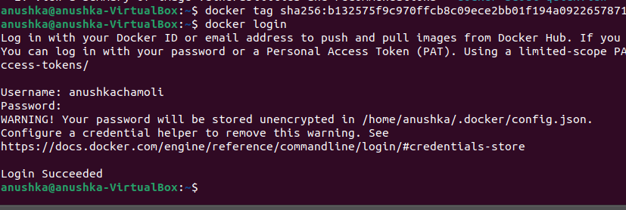

1. Now push the image on Dockerhub using following command.

